Intro to Programming (Python)

Assignment 02

# Overview

In this activity, you learn about built-in functions and operators, what are they, and how you use them. You also learn how to create demonstration scripts and document your knowledge.

This assignment includes the following tasks:

1. Watch the module videos.
2. Read a book chapter.
3. Review some web pages.
4. Watch the additional videos.
5. Apply your knowledge.
6. Document your knowledge.
7. Submit your work.

We are trying to answer the following questions:

* What is data?
* How do you declare and assign values to constants and variables?
* How do you work with data types?
* What are Functions (Methods)?
* What are Operational Constructs (Operators)?
* How do you use concatenation?
* What is the difference between value and reference types?

# Assignment Steps

The following assignment steps ask you to read about, perform, and write about programming.

***Note:*** *Course assignments help you learn through* ***reading****,* ***watching*** *demonstrations,* ***performing*** *programming in Python, and reflecting on what you learned through* ***writing****. You are strongly encouraged to continue your learning by experimentation.*

## Step 1 - Watch the following videos

Please watch my course videos. You can find the course video **links on Canvas**.

## Step 2 - Read a book chapter

Please **read chapter two** in your textbook. You **do not have to perform the exercises or type in the code**, but it is best if you open the script files as you read about them. You can find the downloadable **book files** **on Canvas** for your convenience.

## Step 3 - Review the following web pages

Please review the following web pages:

1. <http://www.learnpython.org/en/Variables_and_Types>(external site)
2. <http://www.learnpython.org/en/Basic_Operators>(external site)

## Step 4 - Additional Videos

There are lots of free videos on the internet, and sometimes it helps to see how different people explain the same topics. So, please watch the following:

* Variables - <http://www.youtube.com/watch?v=667ZeuZ0Q8M> (external site)
* Python Tutorial for Beginners 2: Strings - Working with Textual Data <https://youtu.be/k9TUPpGqYTo> (external site)

## Step 5 - Apply your knowledge

Now that you have reviewed the websites and videos, try to create a new program that asks the user to input 2 numbers then prints out **the sum, difference, product, and quotient**.

### Step 5.1 Create a Python Script

Create a python script file with the code shown in Figure 1.

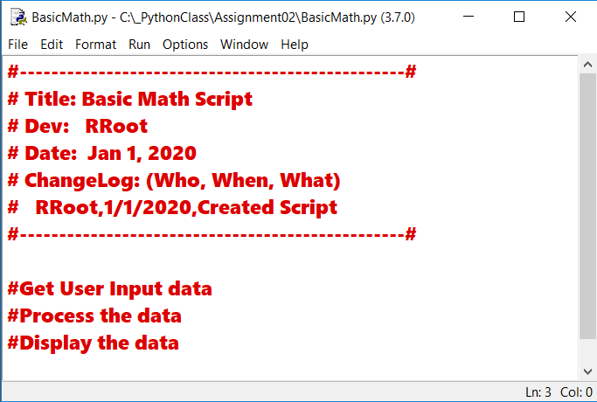

Figure 1. The code in BasicMath.py

### Step 5.2 Save your script to a folder

Save the python script **file** **as** **BasicMath.py** in a **new sub-folder** **called _PythonClass\Assignment02 (**you created the folder you created the **_**PythonClass folder in Module 01). Please use the C: Drive on a Windows OS or the Documents folder on a Mac OS (using the Desktop on either OS is not recommend).

### Step 5.3 Run Your Script

Add code to the script to capture user input data, process that data, and display the resulting data.

### Step 5.4 Run Your Script

With the script created and saved in the proper location, run the script in an OS command/shell window, and capture an image of it working on your computer (Figure 2).

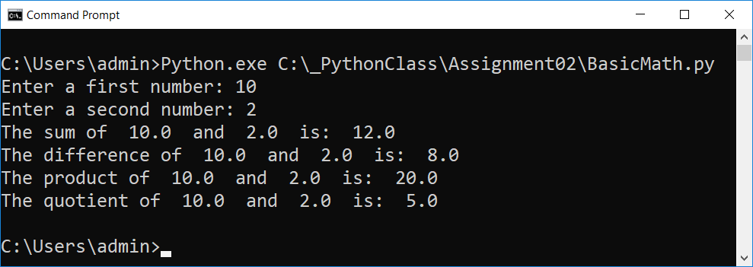

Figure 2: A screenshot of the script running in a command window.

## Step 6 - Document your knowledge

After you have created and tested your Python script, create a document describing the steps you took in performing this assignment.

**Notes:**

* All resources for this assignment are found in the lectures, recommended reading, or recordings specified in the class syllabus. You do not need to locate additional resources outside of these.
* Your document **must look professional** to get full points! Use my example template and video, in the General Files and Topics module, as a guide for what I expect a professional paper to look like. Make sure you format it like a college paper instead of a text message. Things like your **name, date, class, citations, introductory and summary paragraphs** are always expected! So, not putting these in the document will cost you! ([*See this video for help*](https://youtu.be/9ojhSW9ljjo)!)
* Please **save** your files as a PDF file called **Assignment02_YourNameHere.pdf.** Here is an example from Google Docs, but it is similar in most text editors!

**Important**: Make sure to include an introduction and summary, as well as a heading. It does not have to be perfect, but you won't get credit for it if you turn in a simple blob of text! watch this video to help you understand what I am looking for: [Creating Professional Documents](https://youtu.be/9ojhSW9ljjo)

## Step 7 - Submit your work

Now place your document with the Python script in the Assignment02 folder, then Zip this folder into a “.zip” file before finally uploading the file to the class assignment page on Canvas.

Congratulations! You are done!